# Assignment -3

Build CNN Model for Classification Of Flowers

# Question-1:

* Download the Dataset

**SOLUTION:**

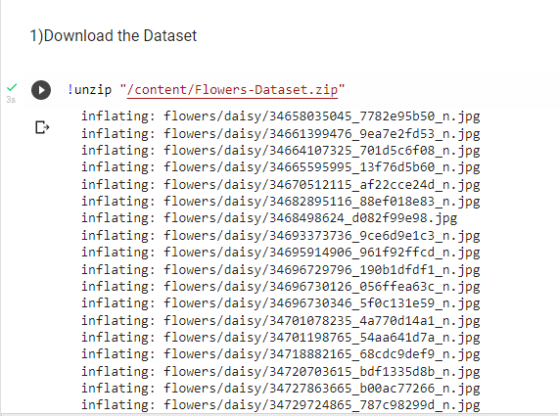

# Question-2:

* Image Augmentation

**SOLUTION:**

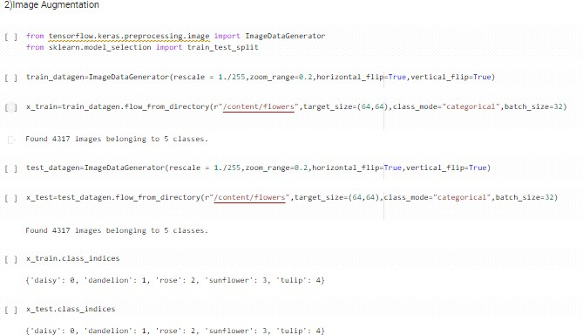

# Question-3:

* Create Model & Add Layers

**SOLUTION:**

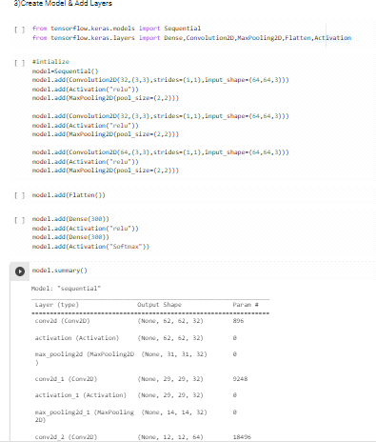

# Question-4:

* Compile The Model

**SOLUTION:**

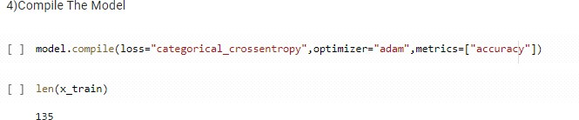

# Question-5:

* Fit The Model

**SOLUTION:**

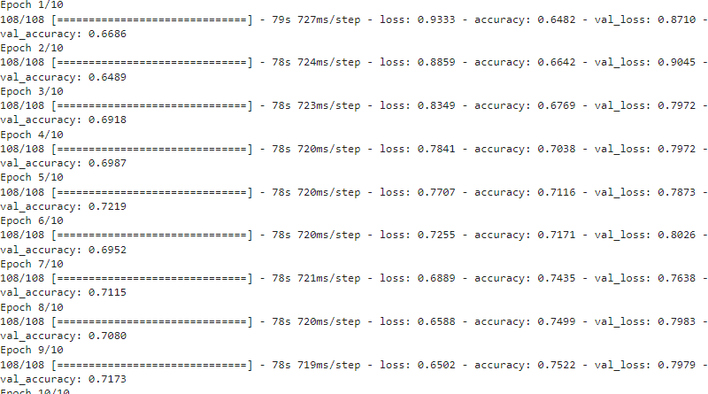

# Question-6:

* Save The Model

**SOLUTION:**



# Question-7:

* Test The Model

**SOLUTION:**

